Hey Reader!

This is Goppi V P. you are going to read about my first day lessons of introduction to embedded systems

## **Ohms law**

The voltage of the conductor is directly propositional to current flowing through it

V=I×R

R=constant (Resistance)

I=current

## **Kirchoff’s current law**

The sum of in coming current in a node or junction is equal to sum of leaving current of a junction or node

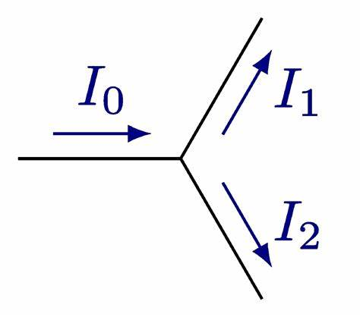

# **Kirchoff’s voltage law**

Sum of voltage drops around a closed loop is equal to zero



## **Basic circuit simulation**

Components used

R=100Ω, V=5v, Green LED

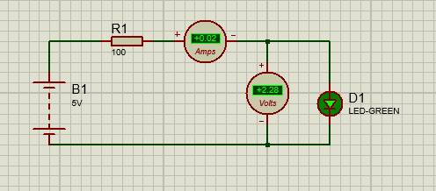

Observed reading

Voltmeter=2.28v

Ammeter=0.02A

I’ve also observed by changing the voltage in battery and changing the values of resistor.

Thats all for today. I’m signing off see you tomorrow………..